1. **CUSTOMER STATEMENT OF REQUIREMENTS**

**Problem Statement**

The abundance and variety of food within AUAF’s international campus is of significant importance. The diverse community of people residing in campus including students, faculty, and stuff have diverse routines and likings. Along with the cafeteria, a branch of the famous and successful fast food delivery company, Yummy, is now present within the campus serving a variety of foods. However, the AUAF community as well as Yummy’s staff face several problems. Students have tight schedules, especially in the evening, and processing their orders is stretched and time consuming. The same applies for faculty and staff. As for the Yummy, it has only two staff members, a cashier and a cook, to carry out all their activities. This makes the work of the cashier extremely difficult as he has to take orders, call the chef about the orders, deal with payments, and so on.

To tackle these issues, we propose to develop a web application that will serve as an online food ordering system so both the AUAF community and Yummy’s staff will benefit from a streamlined process that the web application will provide. The ever so basic notion is that the web application will enable customers to order food and similarly enable the Yummy staff to take orders and process them effectively.

1. **SYSTEM REQUIREMENTS**
2. **Functional Requirements**

**Table 1. Functional requirements for Yummy online ordering web application.**

|  |  |  |
| --- | --- | --- |
| ID | Priority Weight | Requirement |
| REQ-1 | 5 | The system shall allow users to register for account |
| REQ-2 | 4 | The system shall allow users to login |
| REQ-3 | 1 | The system shall allow users to change account details |
| REQ-4 | 4 | The system shall allow users to place orders for food items |
| REQ-5 | 4 | The system shall allow users to checkout orders to cart |
| REQ-6 | 3 | The system should allow users to remove orders from cart |
| REQ-7 | 5 | The system shall allow Yummy to view orders |
| REQ-8 | 2 | The system shall allow users to contact Yummy |
| REQ-9 | 4 | The system shall allow users to log out |
| REQ-10 | 1 | The system shall inform users that their orders are placed |
| REQ-11 | 1 | The system shall allow users to browse the site and view food items. |

1. **User Interface (UI)**

In order to avoid any confusion in terms of identification of requirements defined by the customer and the developer team’s understanding, we decided to create a mockup of the system-to-be that will serve as a prototype. This will give both Yummy and developer team the chance to ensure that this is the system that they want and also what we are required to develop. Below is a snapshot of possible pages and elements for the system. We may add or remove certain parts as we develop the application. Most importantly, we have

**Home Page**

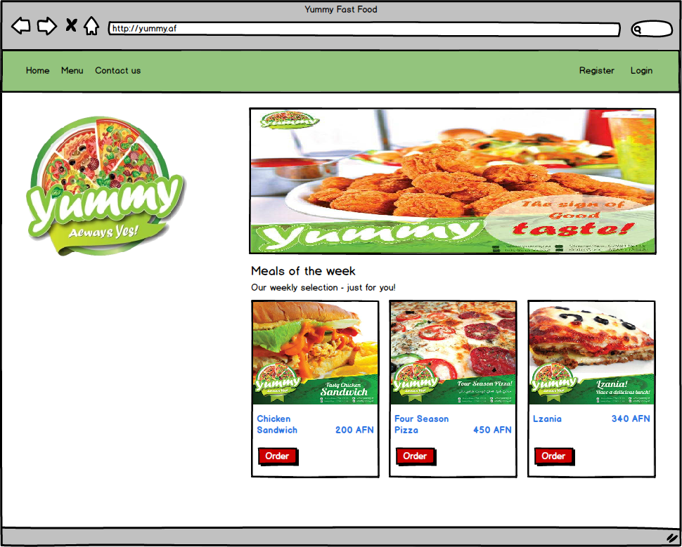

**Menu**

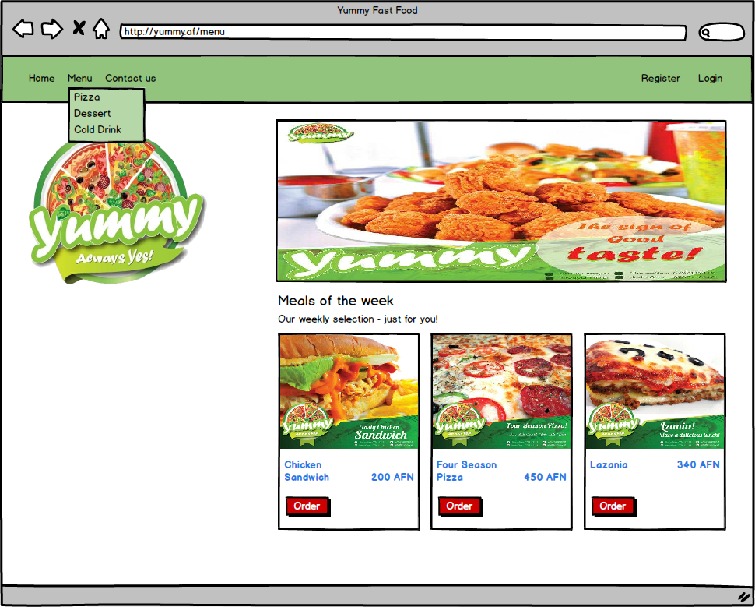

**Detailed description of a food item**

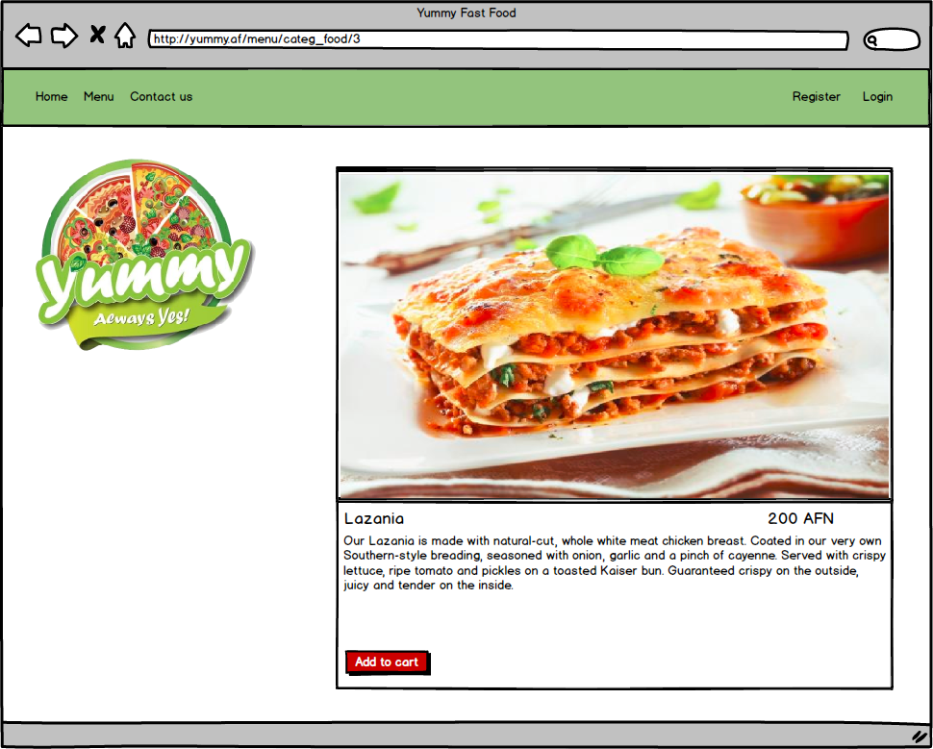

**Shopping cart page**

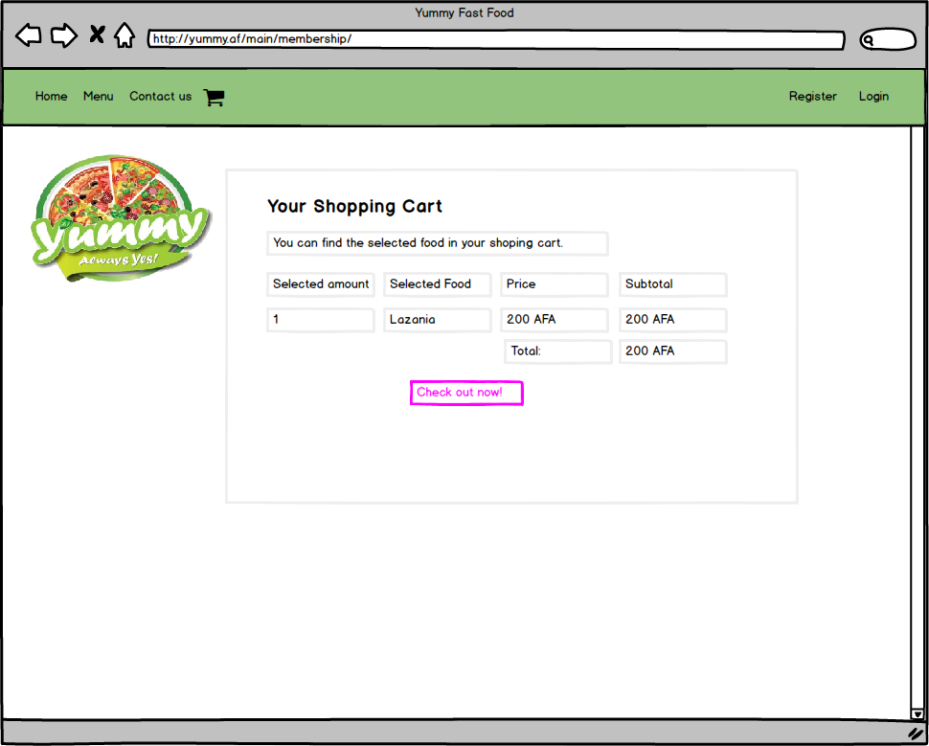

**Checkout page**

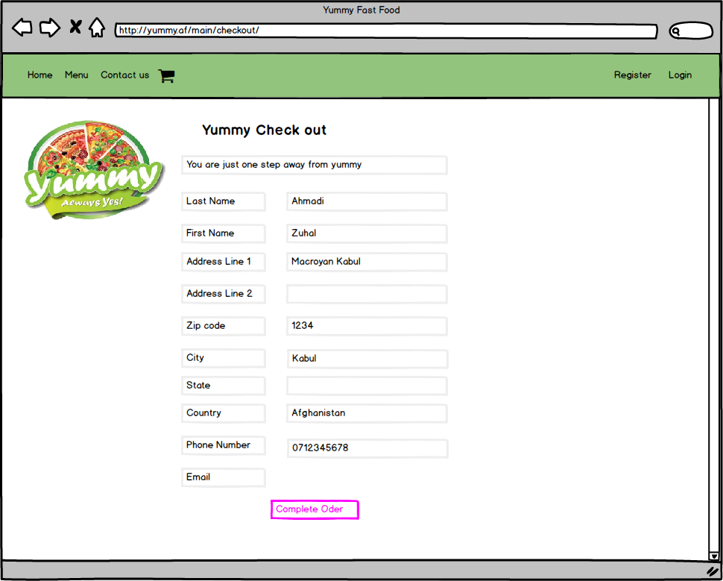

**Login page**

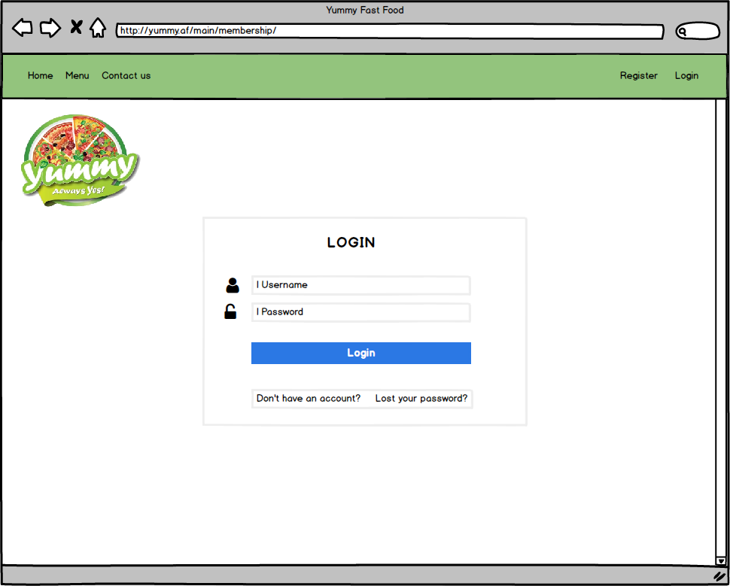

**Contact us page**

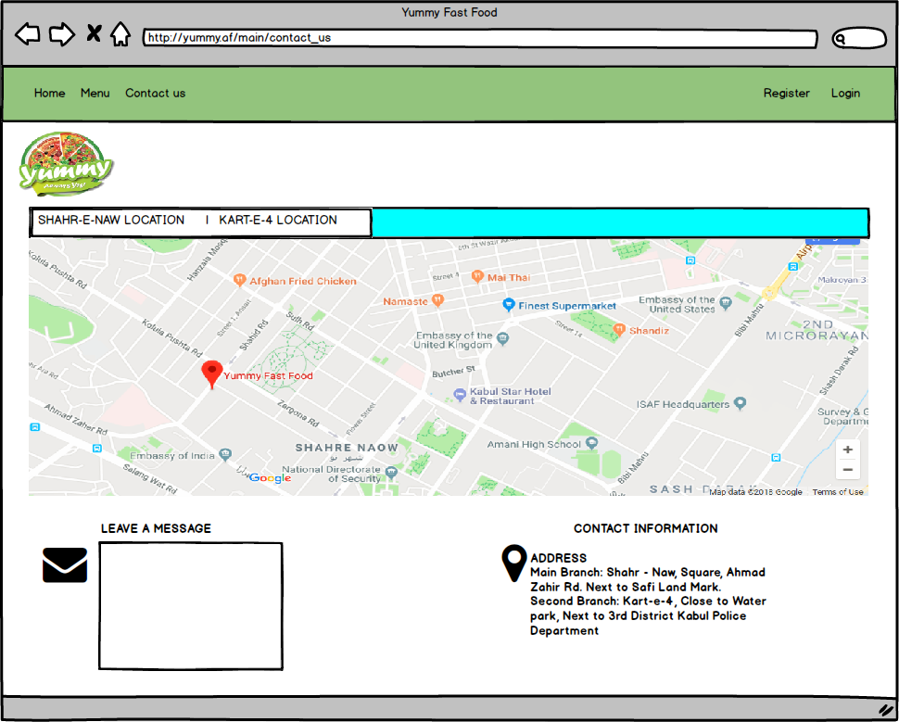

1. **USE CASE DIAGRAM**

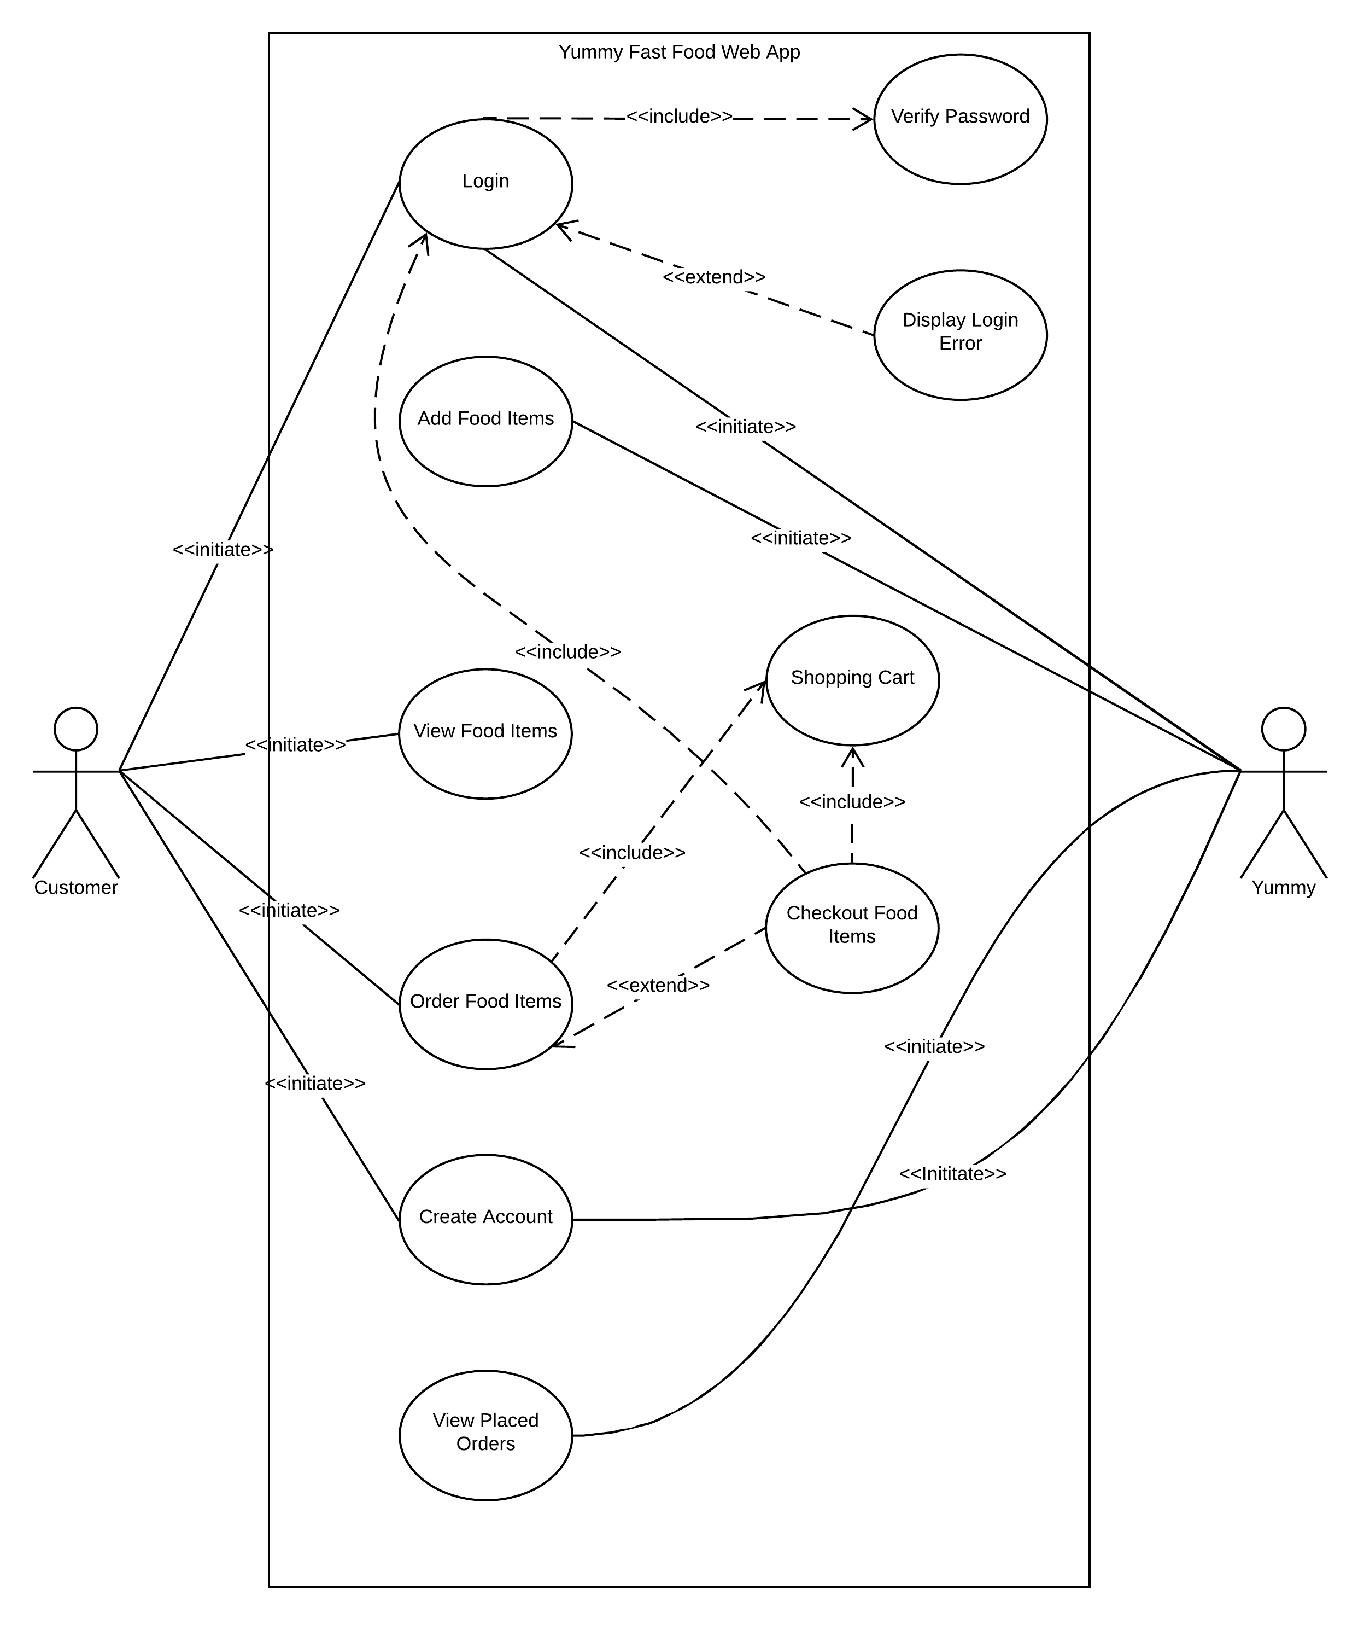

1. **DETAILED USE CASE SCENARIOS**

In this section, a detailed use case for every possible individual module is presented.

|  |  |  |  |
| --- | --- | --- | --- |
| Use Case UC-1 | | | Register Account |
| Related Requirements: | | | REQ-1, REQ-8 stated in Table 1 |
| Initiating Actor: | | | Any of: Customer, Yummy |
| Actor’s Goal: | | | To create an account in the web application. |
| Participating Actors: | | | TBD |
| Preconditions: | | | Make sure the user is not already registered in the system with the same email address the user provides at the time of registration. |
| Postconditions: | | | N.A. |
| Flow of Events for Main Success Scenario: | | | |
| → | 1. | The user submits the required information for account creation. | |
| ← | 2. | The system responds with a message that the account is successfully created. | |
| Flow of Events for Extensions (Alternate Scenarios): | | | |
| ← | 2.a | The system responds with a message that the account creation failed. | |

|  |  |  |  |
| --- | --- | --- | --- |
| Use Case UC-2 | | | Login |
| Related Requirements: | | | REQ-2, REQ-3 stated in Table 1 |
| Initiating Actor: | | | Any of: Customer, Yummy |
| Actor’s Goal: | | | To login to the system. |
| Participating Actors: | | | TBD |
| Preconditions: | | | Make sure the user is registered in the system. |
| Postconditions: | | | The user shall have the ability to login to the system. |
| Flow of Events for Main Success Scenario: | | | |
| → | 1. | The user submits authentication credentials, including the username and password. | |
| ← | 2. | The system logs in the user. | |
| Flow of Events for Extensions (Alternate Scenarios): | | | |
| ← | 1.a | The system verifies user credentials. | |
| ← | 2.a | The system responds with a message if the user provides invalid credentials. | |

|  |  |  |  |
| --- | --- | --- | --- |
| Use Case UC-3 | | | View Food Items |
| Related Requirements: | | | REQ-10 stated in Table 1 |
| Initiating Actor: | | | Customer |
| Actor’s Goal: | | | To login to the system. |
| Participating Actors: | | | TBD |
| Preconditions: | | | None |
| Postconditions: | | | None |
| Flow of Events for Main Success Scenario: | | | |
| → | 1. | The user can view detailed information about an item. | |
| ← | 2. | The system provides the user with detailed information. | |

|  |  |  |  |
| --- | --- | --- | --- |
| Use Case UC-4 | | | Order Food Items |
| Related Requirements: | | | REQ-2, REQ-4, REQ-5, REQ-9 stated in Table 1 |
| Initiating Actor: | | | Customer |
| Actor’s Goal: | | | To place orders in the system. |
| Participating Actors: | | | TBD |
| Preconditions: | | | Make sure the user is logged in to the system. |
| Postconditions: | | | The user is order will be placed in the system. |
| Flow of Events for Main Success Scenario: | | | |
| → | 1. | The user submits orders. | |
| ← | 2. | The system responds with a message stating that their orders are placed. | |
| Flow of Events for Extensions (Alternate Scenarios): | | | |
| ← | 2.a | The system will notify the user that they need to log in. | |
| ← | 2.a | The system responds with a message stating that their orders are placed. | |

|  |  |  |  |
| --- | --- | --- | --- |
| Use Case UC-5 | | | Order Placed Orders |
| Related Requirements: | | | REQ-6 stated in Table 1 |
| Initiating Actor: | | | Yummy |
| Actor’s Goal: | | | To view placed orders in the system. |
| Participating Actors: | | | TBD |
| Preconditions: | | | Make sure the user, in this case Yummy, is logged in to the system. |
| Postconditions: | | | The system shall mark placed orders as completed. |
| Flow of Events for Main Success Scenario: | | | |
| → | 1. | The Yummy user views placed orders. | |
| → | 2. | The Yummy user process orders by marking them as processed. | |

|  |  |  |  |
| --- | --- | --- | --- |
| Use Case UC-6 | | | Add Food Items |
| Related Requirements: | | | REQ-11 stated in Table 1 |
| Initiating Actor: | | | Yummy |
| Actor’s Goal: | | | To add new items to the website. |
| Participating Actors: | | | TBD |
| Preconditions: | | | Make sure the Yummy user is logged in to the system. |
| Postconditions: | | | N.A. |
| Flow of Events for Main Success Scenario: | | | |
| → | 1. | The Yummy user adds new items in the database. | |
| ← | 2. | The system responds with a message stating that the items are added. | |
| Flow of Events for Extensions (Alternate Scenarios): | | | |
| → | 2.a | The system will prompt the Yummy user if an item is already in the database. | |

1. **INTERCTION DIAGRAMS**

As agreed in the class, instead of interaction diagrams, we have designed and developed an interactive mockup or prototype for our solution that demonstrates the processes and interactions within the system in a more elegant way and gives our client an opportunity to experience what they want prior to the development of actual solution.

1. **CLASS DIAGRAM**

Tremendous effort has been made in designing the class diagrams to ensure that it will be reflected in the system with minimal modifications. However, there are areas that are subject to change as we progress toward developing the actual solution. Below is a holistic view of the class diagram for Yummy Fast Food online web application.

